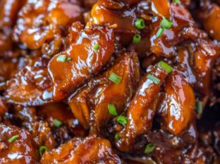
Easy Bourbon Chicken
Prep Time 15 minutes Cook Time 25 minutes
4 Servings

Ingredients
1 lb boneless skinless chicken breasts
3 tbsp cornstarch divided
½ tsp salt
¼ tsp black pepper
2 tbsp oil
1 clove garlic minced
Sauce
½ cup water
¼ cup apple juice
2 tbsp bourbon
¼ cup chicken broth
1/3 cup lite soy sauce, low sodium
3 tbsp ketchup
1 tbsp apple cider vinegar
½ cup packed light brown sugar
¼ tsp onion powder
¼ tsp ground ginger
1/8 tsp crushed red pepper flakes

Directions
- Cut the chicken into 1-inch pieces and in a large bowl toss it with 2 tablespoons of the cornstarch, salt, and pepper.
- Add oil into a large skillet on medium-high heat. Cook the chicken pieces in the skillet for 3 minutes each side.
- Remove the chicken from the pan. Add in the garlic and cook for 20 seconds until you can just smell it.
- Mix all sauce ingredients together in a large bowl. Add to the pan with garlic and bring to a boil.
- Add the chicken. Cook for 10 to 15 minutes or until the sauce is reduced by about half.
- Combine the remaining tablespoon of cornstarch with a tablespoon of water and stir. Add into the pan and stir.
- Cook until the sauce is thickened. Serve immediately.
Freeze option
Separate into two portions after adding the cornstarch. Freeze one half in a freezer safe container and cook remaining chicken and sauce as directed.

